|  |  |  |  |  |  |
| --- | --- | --- | --- | --- | --- |
| **Data Types** | **When to use** | **Examples** |  |  |  |
| Varchar | Variable size, can’t do other languages | Names in the English language: Jordan, Aliona, Virali |  |  |  |
| Char | Fixed size – Numerical characters | SSN, DOB, DL, Zip codes |  |  |  |
| Nvarchar | Variable size – Can use special characters, good for foreign languages | Names of Chinese cities |  |  |  |
| Nchar | Fixed size – can use all languages and unique characters | Driver’s License using foreign language |  |  |  |
|  |  |  |  |  |  |

**2. What is a Cloud Platform?**

It is the software infrastructure for a cloud service that allows users to create and manage their own accounts.

**3. What is the use of a cloud Platform?**

A cloud gives users a safe place to store files. Users can access, retrieve and maniupulate them anyway they see fit. A cloud is also a way to prevent the loss of files due to a disaster situation.

**4. What are the different cloud platforms we have?**

Azure, AWS, GCP, Alibaba, IBM

**3. Declare and assign values for integer data type and Varchar data type.**

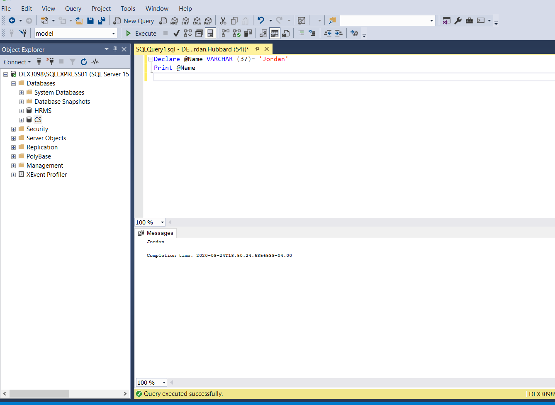

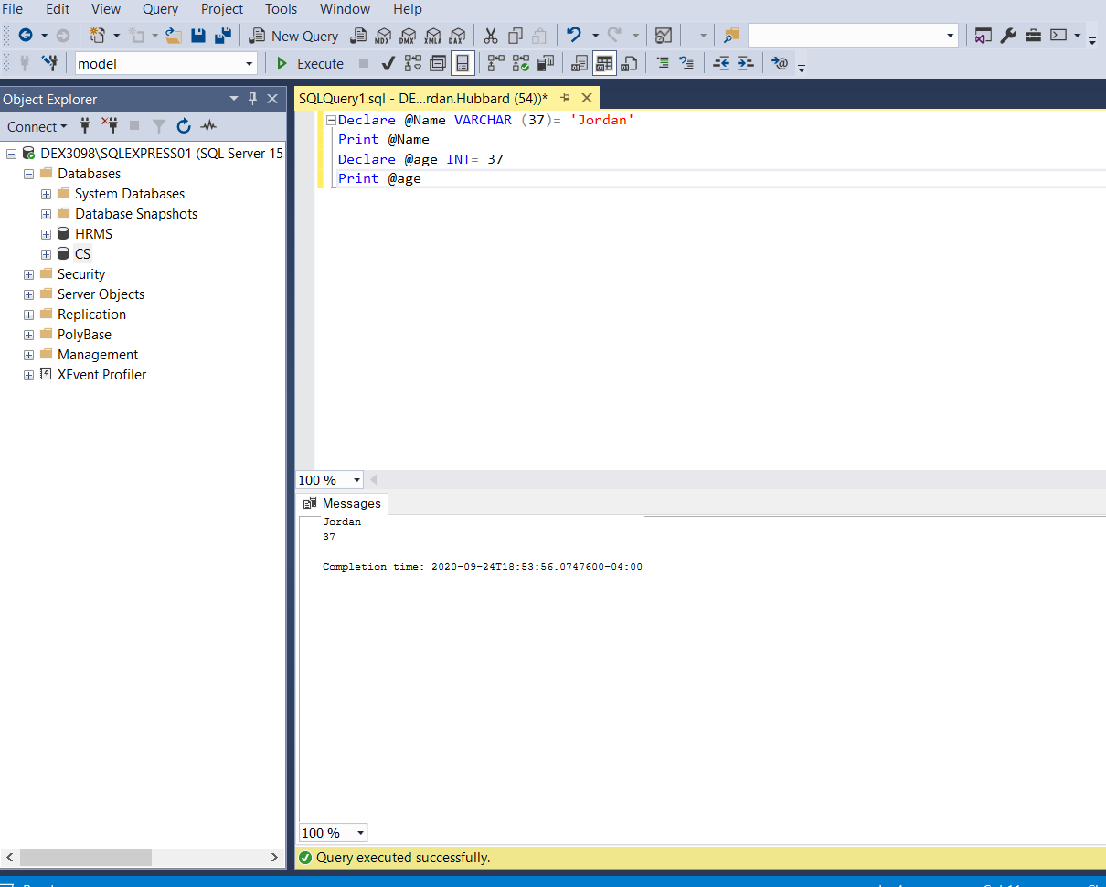

**4. Create two databases (HRMS and CS)**

